**Name of the Experiment:** Parity Generator and Checker

**Objective:**

* To design and implement an Even parity Generator and Even parity checker using XOR

gates) (IC-7486).

**Required Components and Equipments:**

* XOR gates
* Logic State
* Logic Probe(big)

**Experimental Setup:**

**Even parity generator:** First I went to parts and than simulator preemptive. From there I added XOR Gate. I also added a logic state and logic probe. For even parity, I took four logic states. Added the first two gates with an XOR gate and the rest two logic states with another XOR gate. Finally, I added both the XOR gate output with another XOR.

**Even parity checker:** First I went to parts and than simulator preemptive. From there I added XOR Gate. I also added a logic state and logic probe. For even parity, I took five logic states. Added the first two gates with an XOR gate and the rest two logic states with another XOR gate. Then, I added both the XOR gate output with another XOR. Finally, I added the left out logic state which is supposed to be my parity checker with the XOR gate output though another logic state.

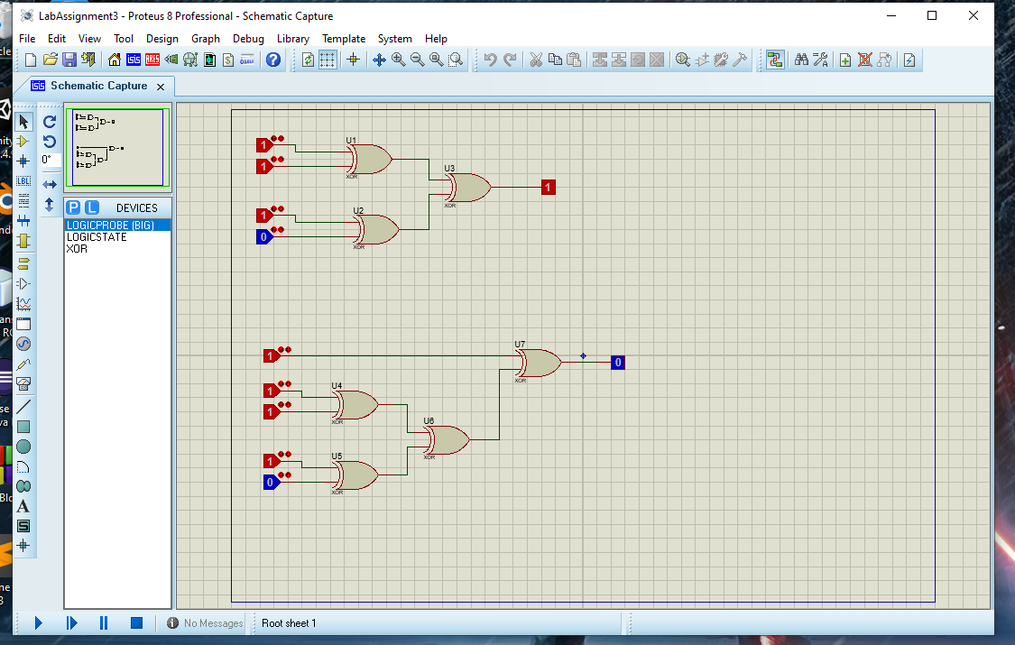

**Results in Tabulated form:**

**Truth Table:**

**a)**

|  |  |  |  |  |
| --- | --- | --- | --- | --- |
| **D3** | **D2** | **D1** | **D0** | **OUTPUT** |
| **0** | **1** | **1** | **1** | **1** |
| **1** | **0** | **0** | **1** | **0** |
| **0** | **0** | **0** | **0** | **0** |
| **0** | **1** | **0** | **0** | **1** |

**b)**

|  |  |  |  |  |  |
| --- | --- | --- | --- | --- | --- |
| **P** | **D3** | **D2** | **D1** | **D0** | **OUTPUT** |
| **0** | **1** | **0** | **0** | **0** | **0** |
| **1** | **1** | **1** | **0** | **0** | **0** |
| **1** | **1** | **1** | **1** | **1** | **1** |
| **1** | **0** | **0** | **0** | **1** | **1** |

**Kmap:**

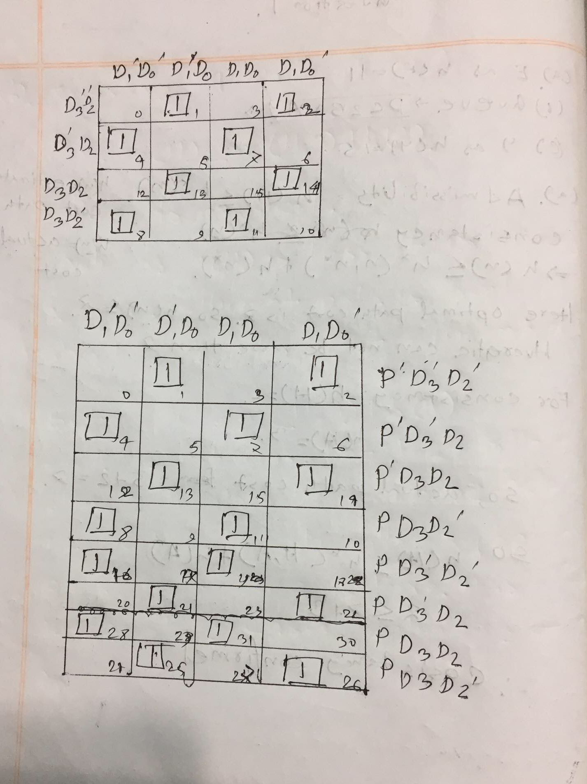

**Discussions (Explanation of the results):**

After generating even parity and using even parity checker,it shows that when the number of 0 is even it gives okay otherwise an error. However, it has some issues. Not always it can detect the changes of bits.